# Project

* Site-21-Api-Ng-Publishing-PostGres-Docker-Fallback
  + Copied from: Site-20-Api-Ng-PhotoManagement
* For the “MySocialConnect-API”
  + dotnet restore
  + dotnet build
  + Go to project : MSC.WebApi
    - dotnet build : to build
    - dotnet run : to run the api

# New Resources

|  |  |
| --- | --- |
| MSC.Core | MSC.WebApi |
|  | Controllers/FallBackController |
|  |  |
|  |  |
|  |  |
|  |  |
|  |  |
|  |  |
|  |  |
|  |  |

# Resources updated

|  |  |
| --- | --- |
| MSC.Core | MSC.WebApi |
|  | Programs.cs |
|  |  |
|  |  |
|  |  |
|  |  |
|  |  |
|  |  |
|  |  |
|  |  |

# Clear Database

* New migrations created
* Clear the users
* dotnet ef database drop
* dotnet ef database update

# Fix NameSpaces For WebApiControllers

Open all controller and change the name space to

namespace MSC.WebApi.Controllers;

# Setup Angular App

## Angular App Build

Follow “Serve Angular from Api” section in the following doc

[020 Project21 -Ng-Publishing-PostGres-Docker-Fallback.docx](020%20Project21%20-Ng-Publishing-PostGres-Docker-Fallback.docx)

Only do below after performing above.

## .gitignore

Do not push the wwwroot folder getting generated in MSC.WebApi to git so add it to .gitignore file

########################

# wwwroot #

########################

## production build is getting pushed to MSC.WebApi/wwwroot folder

wwwroot

# ServeAngular app from API

## Program.cs

After performing above NG app step, provide instructions for the api to server default and static files

app.UseAuthorization();

/***Custom Section Start***/

//Need to serve static content after moving NG SPA deployment to wwwroot folder in the MSC.WebApi

//this will look for index.htm or index.html

app.UseDefaultFiles();

//by default will look for the wwwroot folder and will serve the content from there

app.UseStaticFiles();

/***Custom Section End***/

app.MapControllers();

## Run

Issue command

> dotnet run

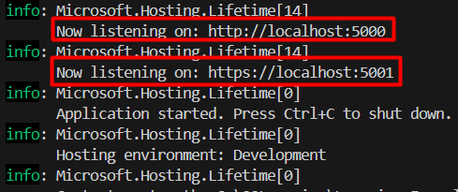

### NG App Access

URL <https://localhost:5001/> will take to the NG app

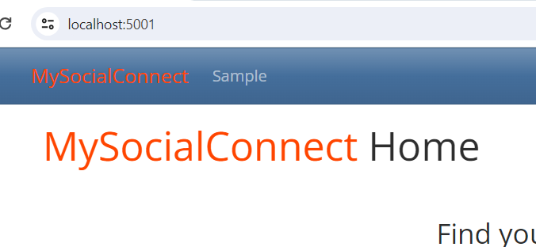

And the NETWORK tab

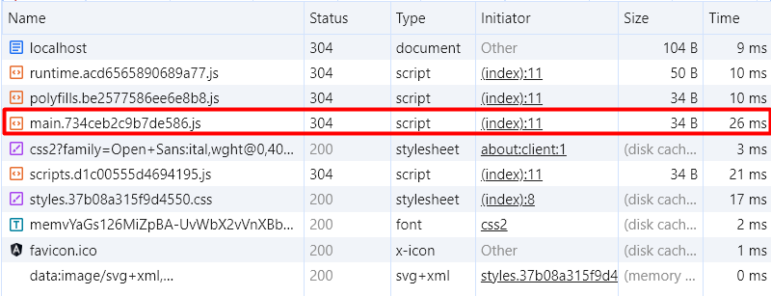

### Swagger Access

URL <https://localhost:5001/swagger> will take to the swagger

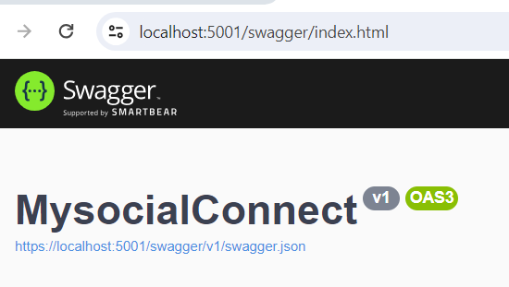

## Issue with Run

* Login as one of the users and it will work.
* Refresh the page and it will show following error
* The reason is, api doesn’t have an end point for members
  + To fix this, will need to create a FallBack Controller and pass the responsibility to angular to handle it

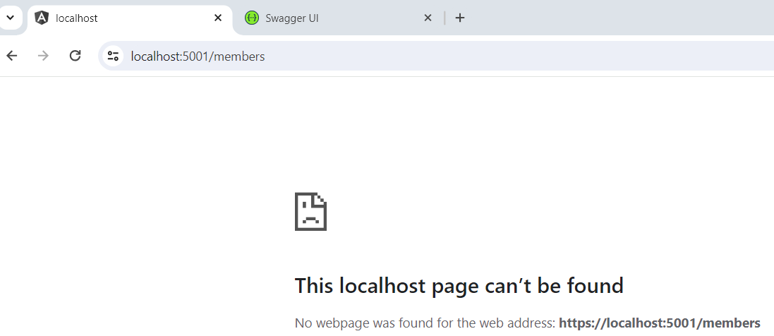

## MSC.WebApi/Controllers/FallBackController

* We’ll need to tell api about the routes that it doesn’t know how to handle.
* We will tell the API to pass that responsibility to Angular App

using System.IO;

using Microsoft.AspNetCore.Mvc;

namespace MSC.WebApi.Controllers;

//Inherit from Controller since we wil be using the view - index.html from angular app

public class FallbackController : Controller

{

    public ActionResult Index()

    {

        //get the index.html from wwwroot folder

        var currentDirectory = Directory.GetCurrentDirectory();

        var indexHtml = Path.Combine(currentDirectory, "wwwroot", "index.html");

        return PhysicalFile(indexHtml, "text/HTML");

    }

}

## Programs.cs

/***Custom SignalR EndPoint End***/

/***Custom Section FallBackController Start***/

app.MapFallbackToController("Index", "Fallback");

/***Custom Section FallBackController End***/

/***Custom Section Seed Data Start***/

## Run Again

Run again, login and then refresh members and it should work